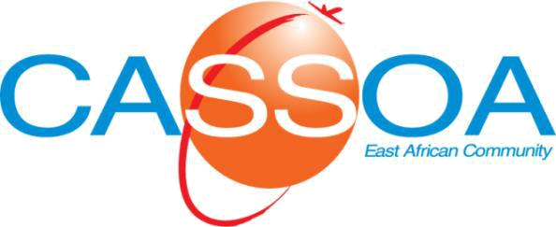

CHECKLIST

CIVIL AVIATION SAFETY AND CL-O-OPS013

SECURITY OVERSIGHT AGENCY October 2017
EXEMPTION FROM DEMONSTRATION FLIGHT HOURS

No. | Description | YES | NO | N/C | N/A
1. | Does the applicant’s request for exemption include the total number of hours it proposes to fly in the reduced programme?
2. | Does the applicant’s request for exemption include a flight experience resume for each flight crew member that it intends to use during the demonstration flight programme?
3. | Does the applicant’s request for exemption include any other documentation of flight crew licenses, total flight time, previous experience with the aircraft being tested, years of experience with the applicant being tested and any other experience in commercial air transportation operations under an AOC?
4. | Does the applicant’s request for exemption include documentation of any other flight crew experience in transport operations such as military?
5. | Does the applicant’s request for exemption include a statement of operator experience with operations as an AOC?
6. | Does the applicant’s request for exemption include a statement of operator experience with aircraft of the same group or type?
7. | Does the applicant’s request for exemption include a statement of operator experience with the aerodromes and areas of en-route operations into which the proposed aircraft will operate?
YES = Requirements met NO* = Requirements not met N/C = Not Checked N/A = Not Applicable

REVIEWING AN APPLICANT’S REQUEST FOR A EXEMPTION FROM THE REQUIRED DEMONSTRATION FLIGHT HOURS

No. | Evaluation Considerations |  |  |  |  |  |  |  |  |  |  |  |  |  |  |  |  | Remarks
1. | To what extent has an air operator certificated in this country used this aircraft previously in commercial air transportation?
2. | To what extent have foreign air operators operated this aircraft?
3. | How familiar is the Authority demonstration team with this aircraft?
4. | For aircraft that have been demonstrated previously in The Civil Aviation (Operation of Aircraft) Regulations, operations, to what extent does the new aircraft affect the applicant’s operation?
5. | To what extent is the applicant’s route structure affected by the new aircraft?
6. | What is the experience level of the flight and cabin personnel in the operation of this type of aircraft under an AOC?
7. | What is the experience level of the flight and cabin personnel in the operation of similar types of aircraft under an AOC?
8. | How does the applicant propose to conduct the demonstration flights, i.e. a few long-range flights, several short-range flights?
9. | What level of management experience exists in the operator with this type or similar types of aircraft operated under an AOC
Recommendation - provide justification for percent of reduction:
Order / CL No:
Notes: 1. A “NO” or “N/C” response on a checklist must be accompanied by reason or comments.
2. A “NO” response to a safety issue finding in an inspection of an organization must be transferred to a CF report for corrective action where applicable.
3. Preceed all comments with the applicable checklist item number or discrepancy number.
Discrepancy Label: (Circle the applicable numeric labels that best describe the discrepancies)
Policy, Procedures, Instructions, Information, Documentation, Controls: |  |  |  |  |  |  |  |  |  |  |  |  |  |  |  | Document Quality
1.Not Specified |  |  |  | 2.Unclear |  |  | Do not comply with: |  |  |  |  | 7.Do not Identify: Who, What, When, Where, How |  |  |  | 8.Unreadable
3.Incomplete |  |  | 4.Inconsistent |  |  |  | 5.  Civil Aviation |  | 6.Guidance |  |  |  |  |  |  | 9.Illegible

10. Resource requirements incomplete (personnel, facilities, equipment, technical data)
1 |  | 2 |  |  | 3 |  |  | 4 |  | 5 | 6 |  | 7 |  | 8 |  | 9 |  | 10

Comments:

Recommendations

Name of Inspector______________ Signature___________________ Date_____________

